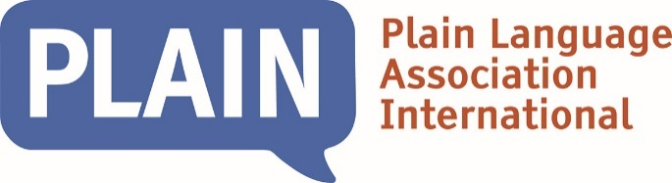

The Christine Mowat Plain Language Achievement Award
  - Template for nominations for the award

Purpose
The Christine Mowat Plain Language Achievement Award is an international award recognizing an outstanding contribution to advancing plain language at the local, regional, national, or international levels.

Eligibility
To be eligible for the Award, a recipient will generally be a PLAIN member, but need not be. The nomination must be made by a PLAIN member, supported by another PLAIN member and at least one other individual active in the plain-language profession (who may be a member of PLAIN but need not be).

Your nominee
I nominate
For their achievement in … (provide a brief statement)

Deadline
Your nomination must be submitted by June 26, 2023.

Criteria
The award may be presented to a person or organization who has significantly advanced plain language as a professional through their work and represented the profession of plain language with the highest integrity and skill. A person’s plain language work can be in any language and take a variety of forms, such as:
- significant research in the field of plain language
- extensive experience in developing and presenting plain language training
- extensive experience in writing or editing documents using plain language
- a body of publications about plain language
- successful leadership in public plain language projects
- significant volunteer contribution to a plain language organization

Your nomination
- Please give us a general overview of your nominee

Please address the following criteria in your nomination. Your nominee does not need to have achieved something in all the criteria.
- Tell us about how your nominee carried out significant research in the field of plain language.

- Tell us if your nominee has extensive experience in developing and presenting plain language training.

- Tell us if your nominee has extensive experience in writing or editing documents using plain language.

- Tell us if your nominee produced a body of publications about plain language.

- Tell us if your nominee has shown successful leadership in public plain language projects.

- Tell us if your nominee made a significant volunteer contribution to a plain language organization.

- Is there any more you would like to add?

Nominator and supporters
The nomination must be made by a PLAIN member, supported by another PLAIN member and at least one other individual active in the plain-language profession (who may be a member of PLAIN but need not be).

Nominating member
 | Name |  |  |  | Email address
Supporting member
 | Name |  |  |  | Email address
Second supporter
 | Name |  |  | Email address
Details of ‘Second supporter’ (if not a PLAIN member)

Please return by email to awards@plainlanguagenetwork.org by June 26, 2023.
Please include a supporting email from the ‘Supporting member’ and ‘Second supporter’ to verify their support for the nomination.

